
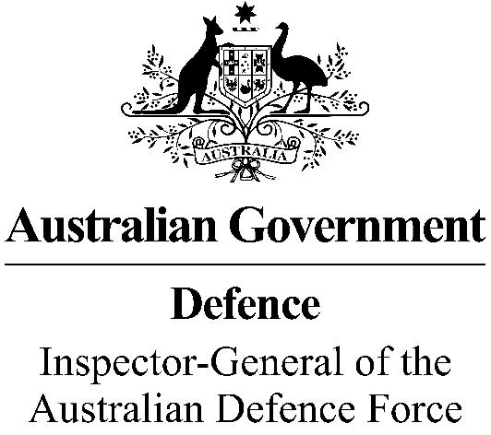
Update to Sharing IGADF information with the Royal Commission
I write this message to make clear what you can and can’t discuss with the Royal Commission into Defence and Veteran Suicide regarding your experience in an Inspector-General of the Australian Defence Force (IGADF) matter.
It is important to reiterate this message does not affect any Court or Tribunal order restricting disclosure of information in respect of an IGADF inquiry or investigation. You must comply with any such order.
IGADF examines sensitive matters. Sometimes the IGADF or an Assistant IGADF will issue directions restricting the disclosure of information in respect of an Inquiry. These directions may concern disclosure of specific information and documents received during the Inquiry i.e. the specific evidence provided to the Inquiry, and information contained in the Inquiry Report.
Any such directions also must be complied with.
However, IGADF non-disclosure directions do not prevent you from sharing with the Royal Commission your personal experiences about your service in the Defence Force and its impact on you – or your personal experiences during engagement with the IGADF and its impact on you. This is because the Royal Commission’s terms of reference require it to look at different matters including issues and themes in relation to suicide and suicide behaviour, risk factors that contribute to suicide, culture and how it impacts on physical and mental wellbeing, and adequacy of support services.
There are protections for people engaging with the Royal Commission. However you must not disclose ‘Protected’ or other security classified information, and it is important that you inform the Royal Commission of any non-disclosure orders or directions that apply.
If you are unclear about the directions that have been made in respect of an IGADF Inquiry, you should contact the Office of the IGADF at Contact us | Inspector-General of the Australian Defence Force (igadf.gov.au).
This message replaces my previous message of April 2023

James Gaynor CSC
Inspector-General of the Australian Defence Force

July 2023

