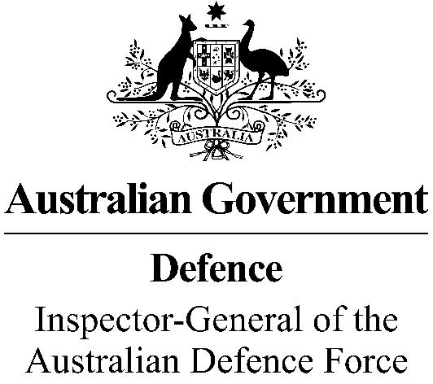

**Office of the Inspector-General of the**

**Australian Defence Force**

**Twenty-Year Review**

In 2023, the Inspector-General of the Australian Defence Force (IGADF) marks its twentieth year of operation.

The IGADF, Secretary of the Department of Defence and Chief of the Defence Force have jointly appointed former Justice, the Hon Duncan Kerr Chev LH SC to conduct a review of the Office of the IGADF. Mr Dennis Richardson AC will also assist the review.

Mr Kerr’s terms of reference are to:

* review the basis by which the statutory office is established, and
* consider and make findings and recommendations, as appropriate, about the functions, operation and composition of the office established to support the IGADF.

Mr Kerr will deliver his report to the IGADF, Secretary and CDF by 31 March 2024.

As part of the review Mr Kerr plans to meet with a range of officials from Defence, other government agencies, ex-service organisations and members of the public.

The purpose of these meetings is to provide Mr Kerr with an understanding of the interaction between IGADF and those areas of Defence, as well as IGADF’s relationship with other government agencies. Mr Kerr is also interested in any views and ideas people might have.