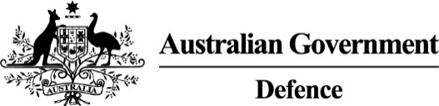 | OFFICE OF THE  INSPECTOR-GENERAL OF THE AUSTRALIAN DEFENCE FORCE
_________________________________________________________________________________________________________________

TERMS OF REFERENCE
REVIEW OF THE OFFICE OF THE INSPECTOR-GENERAL OF THE AUSTRALIAN DEFENCE FORCE
To: Former Justice, Hon Duncan Kerr Chev LH SC
Introduction
- You are appointed to conduct a review into the arrangements and composition of the Inspector-General of the Australian Defence Force (IGADF) and the office established to support the appointment holder.
- Mr Dennis Richardson AC is available for you to consult with on matters you consider appropriate.
Background
- In July 2001, Mr JCS Burchett QC produced an inquiry report into Military Justice in the Australian Defence Force.
- After Mr Burchett’s review, in 2003, the Inspector-General of the Australian Defence Force (IGADF) was established. The IGADF became a statutory office in 2005 under section 110B of the Defence Act 1903.
- IGADF marks its twentieth year of operation in 2023. Over the past twenty years of operation, other bodies have reviewed some aspects of the IGADF’s functions.
- To date there has been no holistic review of the IGADF, its functions, or other arrangements to support the office. It is appropriate for a complete review of the IGADF and its office occur.
Terms
- You are to:
  - review the basis by which the statutory office is established,
  - consider and make findings and recommendations as appropriate about the functions, operation and composition of the office established to support the IGADF, and
  - prepare and deliver to the undersigned a report of findings and recommendations by 31 March 2024.

Administration
- Staff. Necessary staff will be made available to assist you conduct this review.
- Documentation. You are to prepare a report of your findings and recommendations.
[ORIGINAL SIGNED]  James Gaynor CSC  Inspector-General of the Australian Defence Force | [ORIGINAL SIGNED]  Greg Moriarty  Secretary  Department of Defence | [ORIGINAL SIGNED]  Angus J Campbell AO DSC  General  Chief of the Defence Force

20 September 2023

